Anthony Meunier

DeVry University

CIS 355A

Week 1 iLab

Sales Tracking

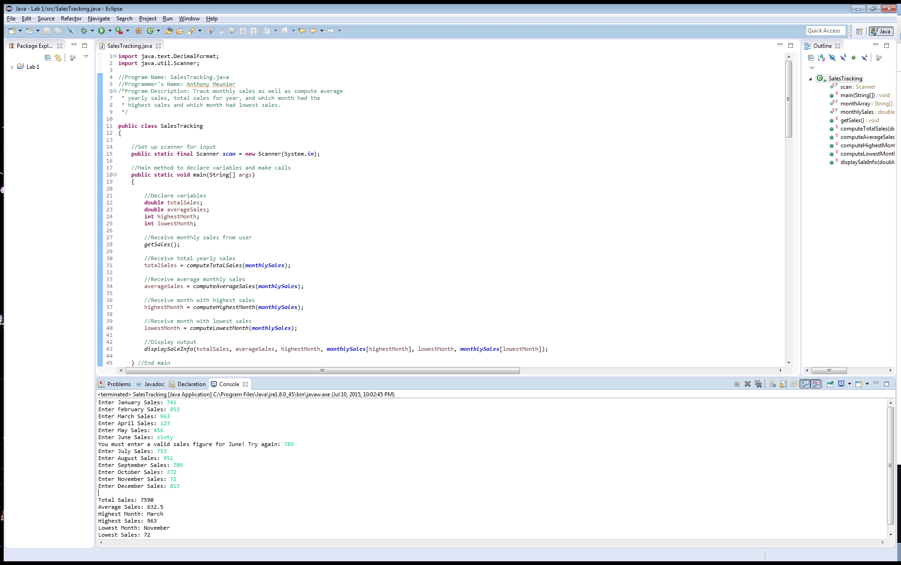

**import** java.text.DecimalFormat;

**import** java.util.Scanner;

//Program Name: SalesTracking.java

//Programmer's Name: Anthony Meunier

/*Program Description: Track monthly sales as well as compute average

* yearly sales, total sales for year, and which month had the

* highest sales and which month had lowest sales.

*/

**public** **class** SalesTracking

{

//Set up scanner for input

**public** **static** **final** Scanner ***scan*** = **new** Scanner(System.***in***);

//Main method to declare variables and make calls

**public** **static** **void** main(String[] args)

{

//Declare variables

**double** totalSales;

**double** averageSales;

**int** highestMonth;

**int** lowestMonth;

//Receive monthly sales from user

*getSales*();

//Receive total yearly sales

totalSales = *computeTotalSales*(***monthlySales***);

//Receive average monthly sales

averageSales = *computeAverageSales*(***monthlySales***);

//Receive month with highest sales

highestMonth = *computeHighestMonth*(***monthlySales***);

//Receive month with lowest sales

lowestMonth = *computeLowestMonth*(***monthlySales***);

//Display output

*displaySaleInfo*(totalSales, averageSales, highestMonth, ***monthlySales***[highestMonth], lowestMonth, ***monthlySales***[lowestMonth]);

} //End main

//Create array with months

**public** **static** **final** String ***monthArray***[] = {"January", "February", "March", "April", "May", "June", "July", "August", "September", "October", "November", "December"};

//Create array to store monthly sales

**public** **static** **final** **double** ***monthlySales***[] = **new** **double**[12];

//Method to receive input from user

**public** **static** **void** getSales()

{

//Prompt user to enter sales for each month

**for** (**int** i = 0; i < ***monthlySales***.length; i = i + 1)

{

System.***out***.print("Enter " + ***monthArray***[i] + " Sales: ");

//Validate input

**while** (!***scan***.hasNextDouble())

{

System.***out***.print("You must enter a valid sales figure for " + ***monthArray***[i] + "! Try again: ");

***scan***.next();

}

//Save in monthly sales array

***monthlySales***[i] = ***scan***.nextDouble();

}

} //End method

//Method to calculate total sales

**public** **static** **double** computeTotalSales(**double** monthlySales[])

{

**double** totalSale = 0;

//Calculate total sales

**for** (**int** i = 0; i < monthlySales.length; i = i + 1)

{

totalSale += monthlySales[i];

}

//Return total sales

**return** totalSale;

} //End method

//Method to calculate average sales

**public** **static** **double** computeAverageSales(**double** monthlySales[])

{

**double** totalSale = 0;

**double** avgSale;

//Calculate total sales

**for** (**int** i = 0; i < monthlySales.length; i = i + 1)

{

totalSale += monthlySales[i];

}

//Calculate average sales

avgSale = totalSale / 12;

//Return average sales

**return** avgSale;

} //End method

//Method to find highest value from monthlySales array

**public** **static** **int** computeHighestMonth(**double** monthlySales[])

{

**double** highestSales = monthlySales[0]; //Store in first element of monthlySales array

**int** highestMonth = 0; //Store highest month

//Find the highest month

**for** (**int** i = 0; i < monthlySales.length; i = i + 1)

{

**if** (highestSales < monthlySales[i])

{

highestSales = monthlySales[i];

highestMonth = i;

}

}

//Return highest month

**return** highestMonth;

} //End method

//Method to find lowest value from monthlySales array

**public** **static** **int** computeLowestMonth(**double** monthlySales[])

{

**double** lowestSales = monthlySales[0]; //Store in first element of monthlySales array

**int** lowestMonth = 0; //Store lowest month

//Find the lowest month

**for** (**int** i = 0; i < monthlySales.length; i = i + 1)

{

**if** (lowestSales > monthlySales[i])

{

lowestSales = monthlySales[i];

lowestMonth = i;

}

}

//Return lowest month

**return** lowestMonth;

} //End method

//Method to display total yearly sales, average monthly sales, the month with highest sales, and the month with lowest sales

**public** **static** **void** displaySaleInfo(**double** totalSales, **double** averageSales, **int** highestMonth, **double** highestSales, **int** lowestMonth, **double** lowestSales)

{

//Round the sales to two decimal places

DecimalFormat decFormat = **new** DecimalFormat("#.##");

System.***out***.println(""); //print blank line

//Display results

System.***out***.println("Total Sales: " + decFormat.format(totalSales) + "\nAverage Sales: " + decFormat.format(averageSales) + "\nHighest Month: " + ***monthArray***[highestMonth] + " \nHighest Sales: " + decFormat.format(highestSales) + " \nLowest Month: " + ***monthArray***[lowestMonth] + " \nLowest Sales: " + decFormat.format(lowestSales));

} //End method

} //End class